**Data Dictionary:**

Demographic table  
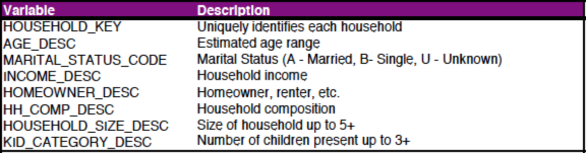

Transaction table:  
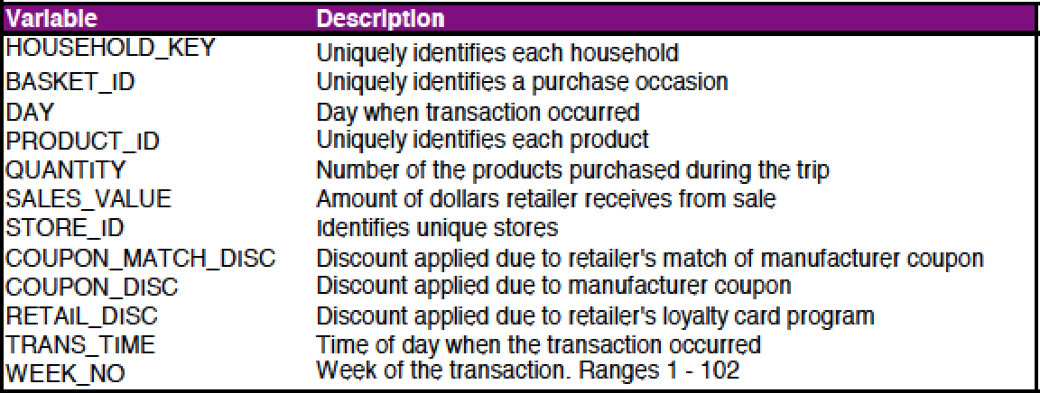

Products Table:  
